Parameters

L = Total length of canoe
L_{p} = Length of paddlers’ “box”
L_{d} = Distance from bow to deepest point of canoe
L_{f} = Distance from bow to first paddler
W = Nominal beam of canoe (the actual beam is in general smaller than this value due to the smoothing of the ramp function
t₁ = Waterline smoothing parameter (bow side)
t₂ = Waterline smoothing parameter (stern side)
d = Depth of canoe below the flange
h = Height of the flange
b = Bow rocker
s = Stern rocker
f(x) = Flare angle of the flange (in general a function of distance along the canoe)
n = Cross-section shape parameter varying between 0 (rounded bottom) to 1 (flat bottom)

Ramp Function

Produces a curve that tends to zero as x approaches negative infinity and is asymptotic to y(x) = x as x approaches positive infinity. The parameter t determines the curvature around the origin (the bend point).

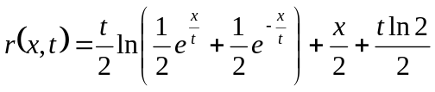

Waterline

Produces a smooth tri-linear waterline curve w(x) where x is distance along the length of the hull.

where r_{stern} and r_{bow} are correction factors given by:

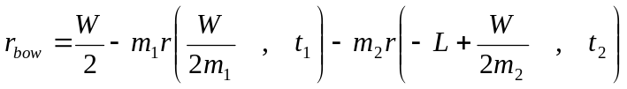
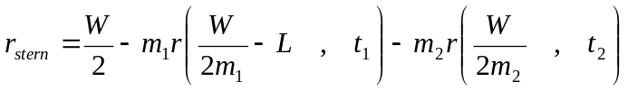

and m₁ and m₂ are scale factors given by:

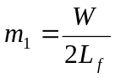
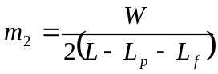

Keel line

Produces a smooth keel line k(x) where x is distance along the length of the hull.

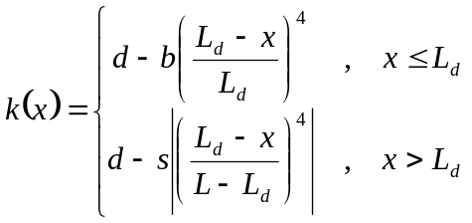

Cross-Section

Creates smooth cross-section curves, each with 4 Bezier spline control points.

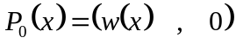
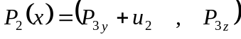
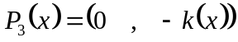

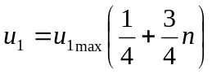
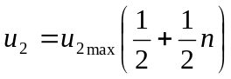

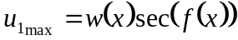
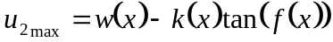

The Bezier spline is defined parametrically for t between 0 and 1.

An additional point is generated at the top of the flange (to be linearly connected to 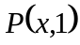 ) according to:

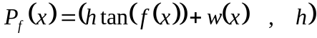

Area of submerged cross-section
w
t = 0
t = 1
z = w t = t_{w}

z
y
A

Given the above parameterization for y and z, and a given waterline height w, find the submerged area A (half the canoe). [Note some of the intermediate variable names given below are identical to some of the canoe parameters—this is out of convenience; there is no relationship between the former and the latter.]

where

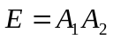
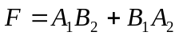
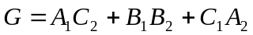
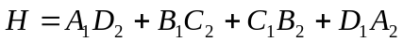
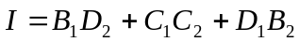
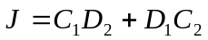
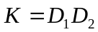

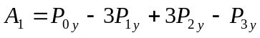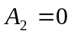
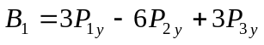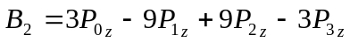
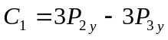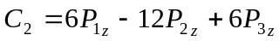
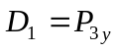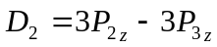

and

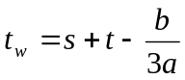

where

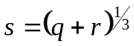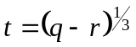
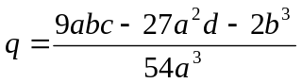
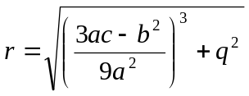
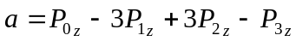
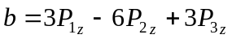
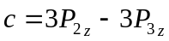
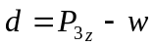 [where w = waterline]

First Moment of Area

See constant definitions above; also:

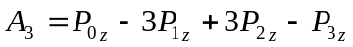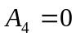
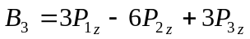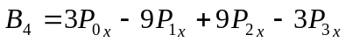
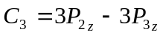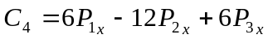
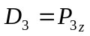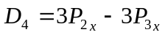

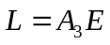
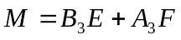
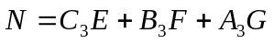
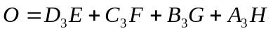
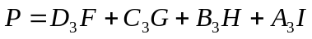
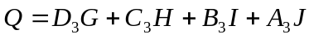
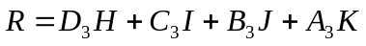
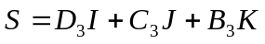
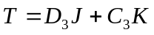
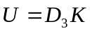

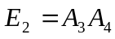
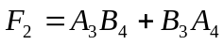
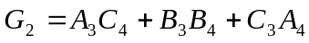
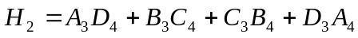
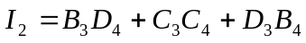
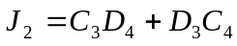
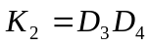

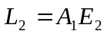
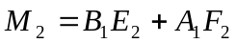
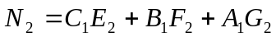
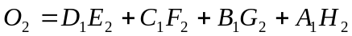
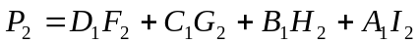
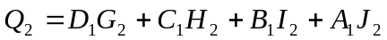
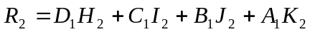
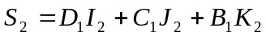
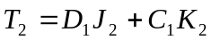
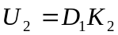

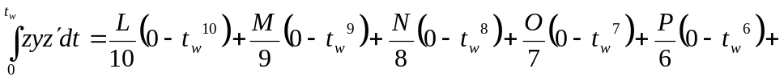
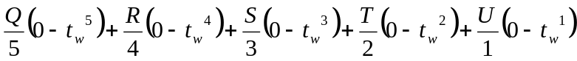

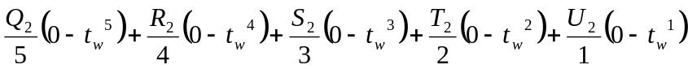
+ area of rectangle with corners (0,0) and the point at t_{w}

Centroid

